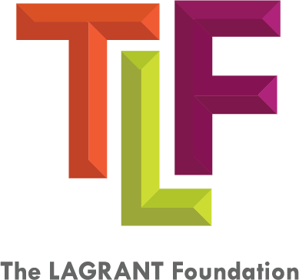

Application for Employment

Applicants who meet the following criteria and have completed the application on the second page (typed, not handwritten) will be considered for The LAGRANT Foundation Recruitment Program:

- Applicant must be:
  - U.S. citizen or permanent resident AND
  - A member of one of the following ethnic groups: African American, Asian American/Pacific Islander, Hispanic/Latino or Native American/Alaska Native.

- Please provide the following in one PDF document:

- Completed Application Form
- Responses to the following questions:
- If you are seeking employment in the advertising, marketing, or PR industry, what is your value proposition to the prospective employer? What makes you the preferred candidate? Please be specific. (min. 150 words)
  - What have been some of your accomplishments so far in your career? (Bullet points or paragraph)
- Resume
- Three writing/work samples (i.e. press releases, media advisories, blog posts, byline articles, graphic design work, relevant college coursework, flyers, brochures, pamphlets, marketing plans, photography, social media posts, etc.)

Please submit completed application to:

Nicholas Neptune
Talent Acquisition Associate
nicholasneptune@lagrant.com
202.494.4931

Mr. Kim L. Hunter
Chairman & CEO
kimhunter@lagrant.com
323.469.8680, ext. 225
323.469.8680, ext. 223

and/or

Application for Employment

Note: All information must be typed. Handwritten applications will not be accepted!
Name (First, Middle Initial, Last)
Current Address
City, State, Zip
Mobile Number Email
Date of Birth (dd/mm/yyyy)

Gender: Female Male Non-binary

Preferred Gender Pronouns: ______________
(e.g. he/his/him, she/hers/her,
they/them/them, etc.)

Please select one:
U.S. Citizen Permanent U.S. Resident DACA Other ______________

Are you currently legally authorized to work in the United States? Yes No

Have you been convicted of a crime (including misdemeanors and felonies) or been found liable for civil fraud or any dishonest act? Yes No

Do you have a legal SS #? Yes No

How did you hear about The LAGRANT Foundation (TLF)? ____________________

Race/Ethnicity:
African American/Black Asian American/Pacific Islander Hispanic/Latinx
Multiracial (list all appropriate racial/ethnic groups) ____________________________________
Native American/Alaska Native
Tribal Affiliation(s) (if Native American/Alaska Native) ______________________________________________
I certify that the information provided is complete and accurate to the best of my knowledge. I understand that falsifying any information may result in the revocation of my application.

Applicant’s Signature Date
(electronic signature accepted)

